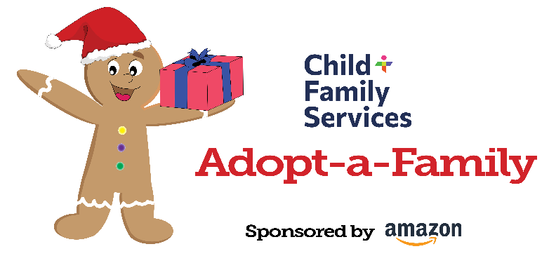
Contact: Garrett Chambers, Public Relations Manager
Email: gchambers@cfsbny.org
Cell: (716) 783-5839

cfsbny.org
844 Delaware Avenue
Buffalo, NY 14209
(716) 842-2750

Amazon Primed to Deliver Joy as Sponsor of the
Child and Family Services Adopt-a-Family Program

Buffalo – Child and Family Services (C+FS) is proud to announce that Amazon will be the lead sponsor for this year’s Adopt-a-Family program.
For more than 20 years, Adopt-a-Family has matched families with donors in the community during the holiday season. Families who benefit from this program receive services such as Foster Care and Adoption Program, Community-Based Counseling Programs, Residential Treatment Program, the Stanley G. Falk School or Youth ACT.
“We couldn’t be more excited to have Amazon sponsoring Adopt-a-Family,” said Mary Czopp, Chief Communications and Development Officer at C+FS. “As the worldwide leader in online shopping, a large percentage of the items bought for families during Adopt-a-Family are purchased on Amazon. The gifts these families receive aren’t just ‘things’ to them; they are holiday memories that will last a lifetime.”
“The work that C+FS does for Western New York is imperative all year round, but it becomes especially more visible and impactful this time of year,” said Carley Graham Garcia, Amazon’s head of community affairs in New York. “The Adopt-a-Family program is an annual tradition that has been relied upon to deliver smiles to children and families during the holiday season. We are proud to support the work that C+FS does for the community, and hope it brings joy to countless more in the coming weeks.”
Over 225 donors in the Western New York community will be matched with more than 275 families exceeding over 1,000 individuals. Adopt-a-Family’s operations will be headquartered at 824 ½ Delaware Avenue through from Tuesday, December 5 through Tuesday, December 19.
To find out more information, visit cfsbny.org/adopt-a-family. If you have any questions, please email adoptafamily@cfsbny.org.

About Amazon
Amazon is guided by four principles: customer obsession rather than competitor focus, passion for invention, commitment to operational excellence, and long-term thinking. Amazon strives to be Earth’s Most Customer-Centric Company, Earth’s Best Employer, and Earth’s Safest Place to Work. Customer reviews, 1-Click shopping, personalized recommendations, Prime, Fulfillment by Amazon, AWS, Kindle Direct Publishing, Kindle, Career Choice, Fire tablets, Fire TV, Amazon Echo, Alexa, Just Walk Out technology, Amazon Studios and The Climate Pledge are some of the things pioneered by Amazon. For more information, visit amazon.com/about and follow @AmazonNews.

About Child and Family Services
Founded in 1873, Child and Family Services relies on its generations of expertise and multi-faceted programs to provide the people of its region with essential resources. C+FS is a not-for-profit organization accredited by the Council on Accreditation and a member agency of the United Way. It serves children, adults, and families in the eight counties of Western New York without regard to race, creed, national origin or economic status.

